Tasks and the back stack

These activities are arranged in a stack the back stack in the order in which each activity is opened

For example, an email app might have one activity to show a list of new messages. When the user selects a message, a new activity opens to view that message. This new activity is added to the back stack. Then, if the user presses or gestures Back, that new activity is finished and popped off the stack.

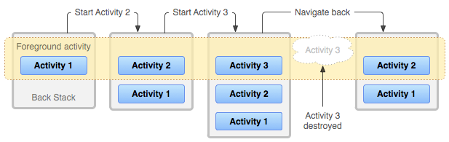
Background and foreground tasks :-
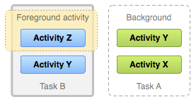

Multiple activity instances :-
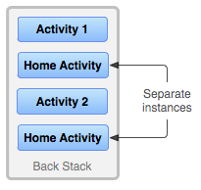

Manage tasks

Defining launch modes

Using the manifest file
When you declare an activity in your manifest file, you can specify how the activity should associate with tasks when it starts.

Using Intent flags
When you call startActivity(), you can include a flag in the Intent that declares how (or whether) the new activity should associate with the current task.

